Document Title
Abstract
Enter some garbage here that describes what this document is for. Then copy it to the purpose sub-section of the Introduction section.
Table of Contents
1 Introduction 2
1.1 Purpose 2
1.2 Scope 2
1.3 Definitions, Acronyms, and Abbreviations 2
1.4 References 2
1.5 Navigation 2
2 Styling [change] 3
2.1 New Section Spacing 3
2.2 Helpful Keyboard Shortcuts 3
3 Documentation Standards [remove] 4
3.1 Title Page/File Name 4
3.2 Table of Contents 4
3.3 Revision History 5
3.4 Footings 5
4 End User Documentation Standards 6
5 Dictionary Maintenance List [List Screen Example] 7
5.1 Fields 8
5.2 Columns 8
5.3 Selection Options 8
5.4 Function Keys 9
6 Dictionary Detail Screen [Regular Screen Example] 11
6.1 Fields 11
6.2 Function Keys 12
7 Revision History 13

Introduction
[change] Some information about what is covered in this document. This header and the level 2 headers 1.1-1.3 should always be in the document in this order. The remaining level 2 headers in this section can be removed if not applicable.

Purpose
[change] Some information about why this document has been created.

Scope
[change] What this document covers. For example, “This document covers processes and menus options of the G/L system.”

Definitions, Acronyms, and Abbreviations
[change/remove] Contains anything that would be helpful to ensure that the reader of this document can understand the terminology used. The following are a few examples used in the G/L System.
- PL – Profit and Loss
- BS – Balance Sheet
- Trial Balance – A list of the account balance or period to date amounts for a given financial period.
- COA – Chart of Account
- GAP – Generally Accepted Accounting Principles

References
[change/remove] add anything here that might be useful. Remove this section if not needed.

Navigation
[change/remove] Add in steps required to get to the part of the system this document covers. The following is an example for the G/L systems transaction import program.
- Login to IBM I (AS400)
- From the user master menu take option 02 for the General Ledger menu.
- Or from the Accounting menu take option 06 for the General Ledger menu.
- Then use option 02
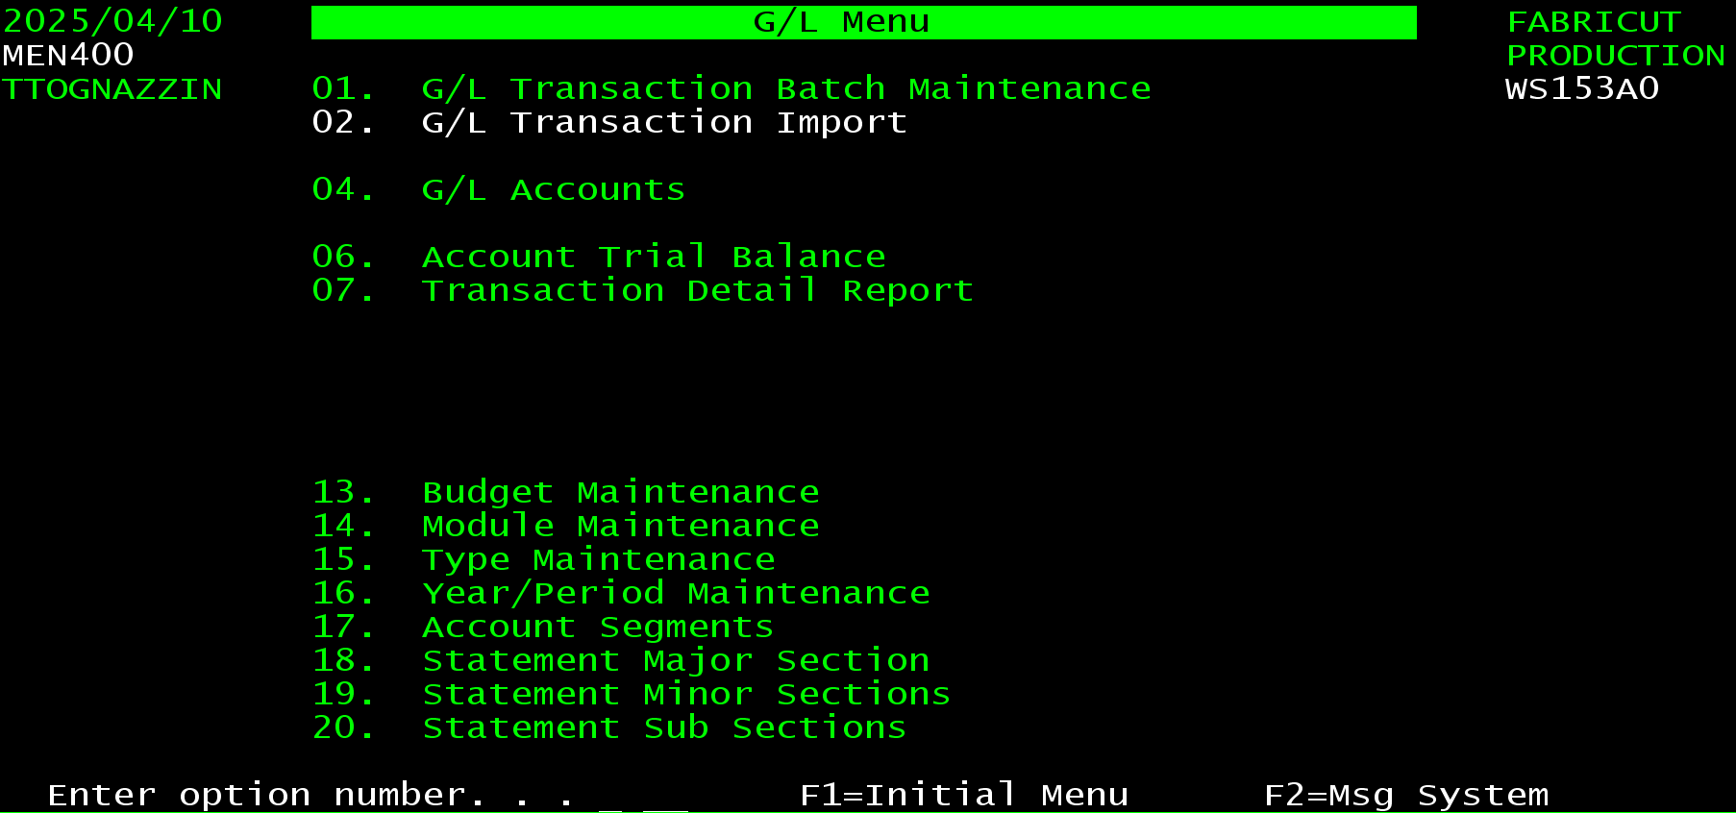

Styling [change]
[change] This would be the start of the next section. It can be called anything. For the G/L Systems Overview document it might be the G/L System Menu. For a document covering a single procedure it might the Functional Flow.

New Section Spacing
Notice that each new section should begin on a new page, use Ctrl + Enter to insert a page break.
Each subsection (Heading 2) does not require a page break but a page break could be entered for larger subsections that should not be split to a separate page.

Helpful Keyboard Shortcuts
Start a page/insert page break Ctrl + Enter
Convert a text to header 1,2, or 3, Alt + Ctrl + 1,2, or 3.
Convert highlighted lines to a standard bulleted list, Ctrl + Shift + l.

Documentation Standards [remove]
This section just covers some of the documentation standards used in this template. It should not be used in documents created from this template.

Title Page/File Name
On the header page, replace the document title and abstract. If the document is for a specific program the title should be the program name followed by the programs description. For example ARR458 is the salesmen invoice report, so the title should be ARR458 – Salesmen Invoice Report. The documents name should follow this convention as well. This ensures that the search in the knowledgebase finds the document by program number or name.

Table of Contents
Leave the table of contents as is, except any time the document is revised, the table must be reloaded.
To do this click anywhere in the table of contents, click updte table, select update entire table, and click Ok.
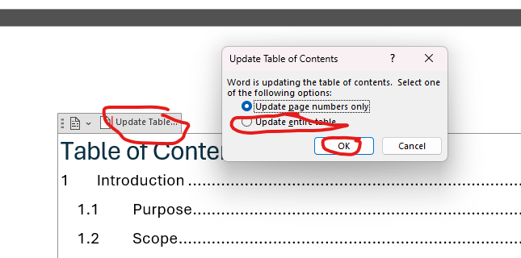

Revision History
The revision history should be last. While it is good information to have, it is not very important to the intended audience. Also, in SharePoint you can get a full revision history.
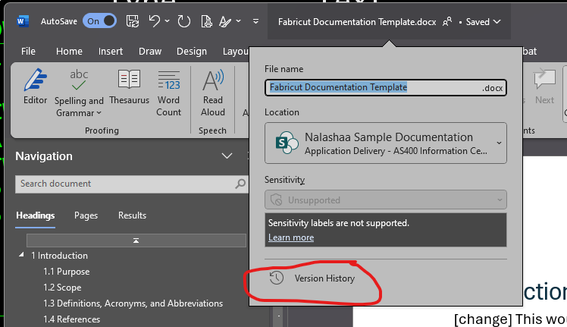

Footings
The page footings should remain the same. The document title is set to match the title entered on the heading page. The heading under the document title is set to be the level 1 heading. This provides information on what part of the page is in. Page numbers include the total number of pages so the reader can get a feel for the size of the document.

End User Documentation Standards
This section covers some standards when documenting screens. This is intended for use in creating end user documentation.
End User documentation should have the standard Introduction section like all documents. It needs a section that outlines the overview of the program or system. If the document is for a single program, it should have a section for each screen. Prompt screens should be omitted unless they are specific to the program being documented.
Inside each screen section, there should be subsection for overview, fields or columns for SFL’s, Options for SFL’s, and Function keys.
When inserting a screen shot, make sure to get the command keys, each screen should start with the full screen shot. Smaller screen sections can be used elsewhere.
The next two sections provide an example of a list panel and detail screen. They should be used as the starting point when documenting one of these types of screens.

Dictionary Master List [List Screen Example]
This screen lists the data dictionaries set up in the system. It is used for maintenance, inquiry and selection. [This section should contain a brief description of the screen. It will be followed by a screen shot, the more detailed information about the screen]
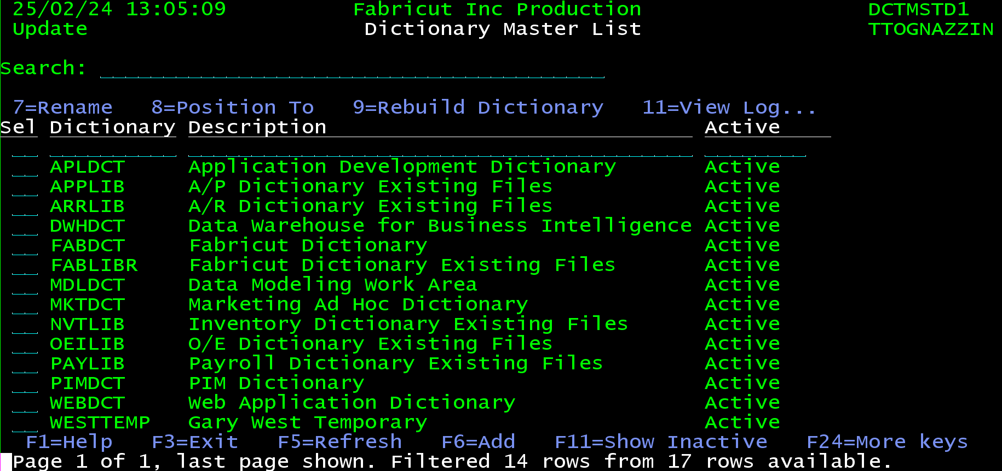
[This section should have more detailed information about the features and use of the screen.]
This program can be called in maintenance, inquiry or selection modes. When in maintenance mode it allows entry, update and inactivation of data dictionaries. In inquiry mode the data can only be displayed. If it is called in selection mode, a diction can be selected with option 1.
The options and command keys will be different based on the mode. For example, in maintenance mode option1 is add, while in selection mode option 1 is select. Another example is that F6=Add is only available in maintenance mode.
The screen features a generic search field to filter the data, a filter screen to filter specific columns and F11 to toggle between showing and hiding inactive dictionaries.
Data dictionaries are set up to define columns for tables. Each dictionary can have many columns in it. DB2 has a limit of 10,000 columns in a table, so that is the most that can be in a dictionary.
Each column has a list of properties. The system also allows notes to be entered for each column. The dictionary will create a reference table named the same as the dictionary. This table is used to define fields on screens and in programs.
Each column also allows default help to be populated. This is used in the template programs to auto generate the system help panels.

Fields
Search Field
The search field allows filtering the data displayed. The filter works on all fields in the data.
For example, if you enter 01 the list will only include lines that have 01 anywhere in them. This could be in a description, numeric or date field. This means if there is a date field in the list, it will include anything in January, anything on the first of the month, anything in 2010-2019, and so on.
The search string also allows multiple words to be entered at once. This means that you can search using more than one selection criteria. It also works with a negative sign to exclude specific records. For example, if you want any entry that includes the word TIME, but you do not want to see time card entries you can enter a search term of TIME -CARD. The list will show only items that contain TIME and do not contain the word CARD.
The search also works with quoted strings using double quotes. An example would be if you only wanted entries with the word TIME and CARD next to each other you could use a search term of "TIME CARD". This will not include any entry that has both words but not together.
Position to Fields
Each column of the list can be sorted and positioned to. The entry line at the top of each column handles this, it is reference to as the position to line. Entering a value in the one of the position to fields will cause the program to sort the list by that column and position to the value entered.

Columns
[For list screens, there should be a detailed list of the columns and what they contain. Each column should be added in the order it is listed on the screen. Bold the column header and follow it by a colon before adding information about the column.]
Sel (Selection): This is the selection column. It allows actions to be taken for each batch in the list. See the Selection Options section for details on what those options are.
Dictionary: This is the name of a data dictionary.
Description: This column contains a description of the dictionary.
Active/Inactive: This field shows whether an entry is active or inactive. Most entries in the system can be inactivated.

Selection Options
[This section contains the selection options for the list. Start by copying one that exist because most of the options are standard. You can use this one as an example, it contains most of the standard options.
The options should start with the option as they are displayed on the screen. Notice there is no space around the = because there is not on the screen. The option should be bold, then followed by a dash and the description of what the options does. Most of this can be copied from the help text.]
This program includes the following options.
1=Create - can be used for entry or select depending on the mode of the program. In entry mode 1 it is an Add. In selection mode it is Select. This opens the G/L Transaction Batch Detail screen in create mode.
2=Update - is used to update an entry in a list.
3=Copy - is used to copy an entry in a list.
4=Deactivate - is used to delete or deactivate an entry in a list.
5=Display - displays information about an entry in a list. It can be labeled as view, display or inquiry depending on the program.
6=Fields - is used to work with the fields set up in the dictionary.
7=Rename - is used to rename an entry in a list.
8=Position To - The position to option is used by placing an 8 in front of an entry in a list and pressing enter. This causes the list to be repositioned so the entry selected is at the top of the screen. This can be useful if a specific section of the list needs to be seen on the screen.
9=Rebuild Dictionary - rebuilds the dictionary reference table. The table is updated when a field is updated, but this option completely rebuilds the table for all fields. A positive side effect of this is that the fields will be added back in alphabetical order.
11=View Log - displays the audit log for an entry. This option is available on many of the newer programs.
13=Reactivate - is used to reactivate or reinstate an inactive or deleted entry in a list.

Function Keys
In addition to the options available to the user, there are function keys on the screen that can be used to filter records quickly and efficiently.
F1=Help - This function key displays any help text associated with the screen for the user.
F3=Exit - Exits the current program. This could go back to one screen or back to an earlier screen. It depends on the progression of the program.
F5=Refresh - Refreshes the current screen. This will reload any information and clear any data that was input. It should be the same as exiting the program and coming back in.
F6 =Add – Provide user with option to add new Dictionary into the system.
F11=Show Inactive – this Function key is used to display or hide inactive entries in a list. By default, inactive entries should be hidden. F11 will show them. Inactive entries should be displayed in red. Most lists allow inactive entries to be reactivated using option 13 =Reactive.
F12=Cancel -Cancels anything entered since the enter key was pressed and returns to the previous screen.
F13= Filters - Displays the filter options for the screen. User can filter based on batch type /Status and sort by
F21=Print/Email List - F21 is the default command key to print a list from a list screen. Printing the list will allow the list to be printed or emailed as a PDF or excel file.

Dictionary Detail Screen [Regular Screen Example]
This screen allows change, display and entry of a single dictionary in the system. [This section should contain a brief description of the screen. It will be followed by a screen shot, the more detailed information about the screen]
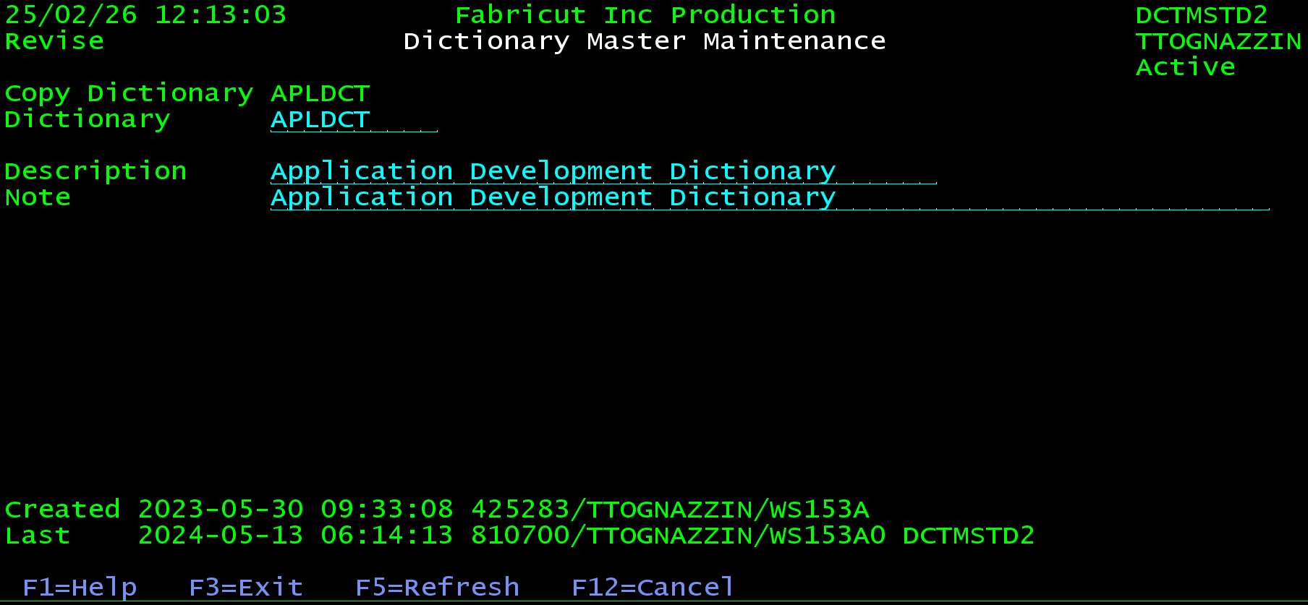
[This section should have more detailed information about the features and use of the screen.]
This screen allows a dictionary entry to be created, updated, viewed, deleted, or reinstated. The mode in the upper left-hand corner below the date shows what action is being performed.

Fields
[List all important fields here. It should list them in the same format as a list screen. Copy most of them from the help text. It does not need to include the header fields, except for the mode. If the screen only has one mode, omit that as well.]
Mode: This field displays the mode of the current program. Many programs can be in different modes. Some common modes are:
- Inquiry/View/Display: These modes essential just show information. They do not allow anything to be updated.
- Create/Add/Entry: These modes indicate that the program is running in entry mode which allows the user to add a new entry of whatever the program is for.
- Update/Revise: These modes means the program is allowing data to be updated.
- Deactivate/Delete: This mode means an entry will be deactivated or deleted.
- Copy: This mode means that an entry is being copied to a new entry.
- Rename: This mode allows changing the name of an entry.
- Reactivate/Reinstate: These modes undoes either a Deactivation or deletion.
Dictionary Name: This is the name of the dictionary. It must be uni
Dictionary Name: This is the name of a data dictionary. Data dictionaries are set up to define columns for tables.
Each dictionary can have many columns in it. DB2 has a limit of 10,000 columns in a table, so that is the most that can be in a dictionary.
Each column has a list of properties. The system also allows notes to be entered for each column. The dictionary will create a reference table named the same as the dictionary. This table is used to define fields on screens and in programs.
Each column also allows default help to be populated. This is used in the template programs to auto generate the system help panels.
Description: This is the description of a dictionary.
Note: This field allows developers to add notes to a dictionary entry. This is just displayed in the dictionary maintenance programs.
Creation string: This is a string that includes a time stamp, qualified job name, and program that created an entry in a file. Each detail screen in the system lists this information. The intent is to provide information about where an entry originated from.
Maintenance String: This is a string that includes a time stamp, qualified job name, and program that last updated an entry in a file. Each detail screen in the system lists this information. The intent is to provide information about where an entry was last maintained.

Function Keys
This screen has the following function keys.
F1=Help - This function key displays any help text associated with the screen for the user.
F3=Exit - Exits the current program. This could go back to one screen or back to an earlier screen. It depends on the progression of the program.
F5=Refresh - Refreshes the current screen. This will reload any information and clear any data that was input. It should be the same as exiting the program and coming back in.
F11=Show Inactive – this Function key is used to display or hide inactive entries in a list. By default, inactive entries should be hidden. F11 will show them. Inactive entries should be displayed in red. Most lists allow inactive entries to be reactivated using option 13 =Reactive.
F12=Cancel -Cancels anything entered since the enter key was pressed and returns to the previous screen.

Revision History
Date | Document  Version | Description | Owner | Reason for Change
Nov/17/2016 | V1.0 | Initial draft | Nalashaa Solutions
Nov/21/2016 | V1.0 | Review initial draft | ABC Financial

[remove the rest of this from a copied template]
This should be last as not to distract from more important parts of the document.
Each document should be versioned. This is a manual process. The document name should end with the version number. For example, this document could be named Documentation Template V1. Once the initial version is done, the Revision history table above will be updated for version 1.
If major changes are made to the document at a future date, the document should be copied to version 2. Then the file name should be changed to include V2 instead of V1. If a smaller change is added the version may be changed to V1.1 and an appropriate entry should be added to the revision table.
A major change would be for something like change to flow or outline of the document. For example, if a system was documented and the system went through an overhaul the entire document covering that system will need to be re-worked, this would be a new version of the document.
A minor change may just be adding new section. For example, if a style section is added to this document it could be changed to version 1.1, so V1.1 in the file name.
Old versions of documents should be moved to an archive folder in the folder their current version is placed in. For example, this document is in the root folder of the AS400 Information Center. If a new version is made, an archive folder should be added to the root folder and version 1 of this document should be put in the archive folder, leaving only the current revision in the root folder.

